CIS1111 Topic 14 – 2-Dimensional Arrays
Calendar
In this program, you will store a calendar month of dates (numbers starting at 1) in a two-dimensional array. Some months have 31 days, others 30, and February has 28 (29 if it’s a leap year, which is a year divisible by 4).
Here is a list of Months, the number of Days in each month, and the Day on which each Month Starts, in 2016, 2017, 2018, and 2019:
Day on which Month Starts
Months Days 2016 2017 2018 2019
January 31 Friday Sunday Monday Tuesday
February 28* Monday Wednesday Thursday Friday
March 31 Tuesday Wednesday Thursday Friday
April 30 Friday Saturday Sunday Monday
May 31 Sunday Monday Tuesday Wednesday
June 30 Wednesday Thursday Friday Saturday
July 31 Friday Saturday Sunday Monday
August 31 Monday Tuesday Wednesday Thursday
September 30 Thursday Friday Saturday Sunday
October 31 Saturday Sunday Monday Tuesday
November 30 Tuesday Wednesday Thursday Friday
December 31 Thursday Friday Saturday Sunday
*except leap year

Given a month name, the name of the starting day of the week, and the year, write a program to store the date (number) of each day in the corresponding array location. Use a two-dimensional array called month of type int to store the generated month dates.
- Declare month to be an array of type int of the proper size and dimensions (weeks and days), and initialize all elements to 0.
- Handle user input as follows:
  - Ask the user for the month name, and match it to the appropriate number of days (hint: use parallel arrays)
  - If the month is February, you need to know the year, and test if it is a leap year to adjust February’s number of days, if needed.
  - Ask the user which day of the week the month starts on, and match it to the proper day number (Sunday being day 1), to determine which position in the two-dimensional array to start storing dates (hint: use parallel arrays)
- Use formatted output to display the month left-aligned, omitting “0” dates (see the output example below)
- Use functions if desired. Allow your main program to loop, allowing the user to ask for an unlimited number of months.

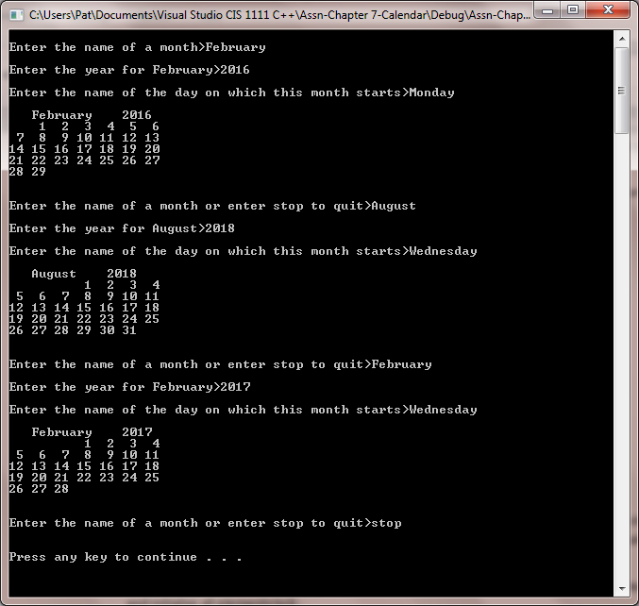

Requirement | Point value
Used a 2-dimensional array of the proper type, size, and initialized to 0 | 2
Handled user input, accounted for invalid input, ask for the proper information as needed | 3
Generated the month correctly, on the correct day of the week, with the correct number of days | 6
Functions and variables were named clearly, and code was well documented | 4
Output was clear and correctly formatted | 5
Total | 20

